**LIFE CYCLE PHASES**

**Service Strategy: Goal, Scope, Processes, and key concepts**

SS – Service Strategy

* ST. mgt.
* Finance ->
* Portfolio ->
* Demand mgt.
* Business Relationship Mgt. ->
* ***Value of creation alignment with customer***

SD – Service Design

ST – Service Transition

SO – Service Operation

CSI – Continual Service Improvement

Center of the mix is service strategy

Surrounded by design, transition, operation

Perspective, position, plan, and pattern of services

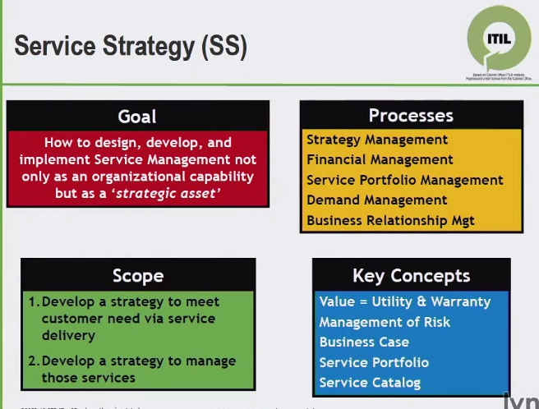

What is strategy?

What are customers looking for?

Value? How it is created how it is delivered

How we exploit?

**Utility –** fit for purpose

**Warranty –** fit for use

**Service portfolio:**

Pipeline services

Catalog services

Retired services

**Service Strategy: Value Creation**

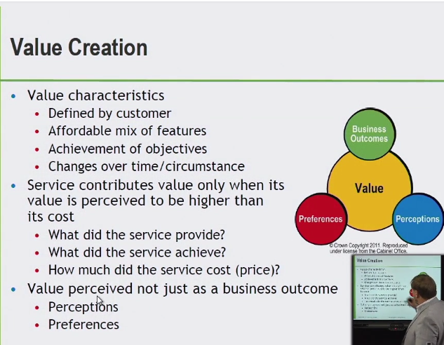

* Achievement of objectives
* Changes over time/circumstance

**If perceived Value>Cost = Service contributes value

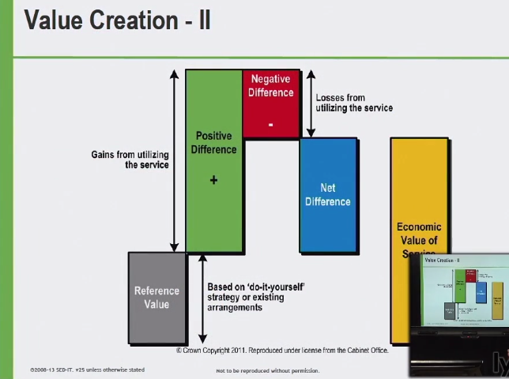

Reference Value + Net Difference = Economic Value of Service

Why service strategy as a phase is valuable to a business

Needs of biz., how are we going to provide services to support needs

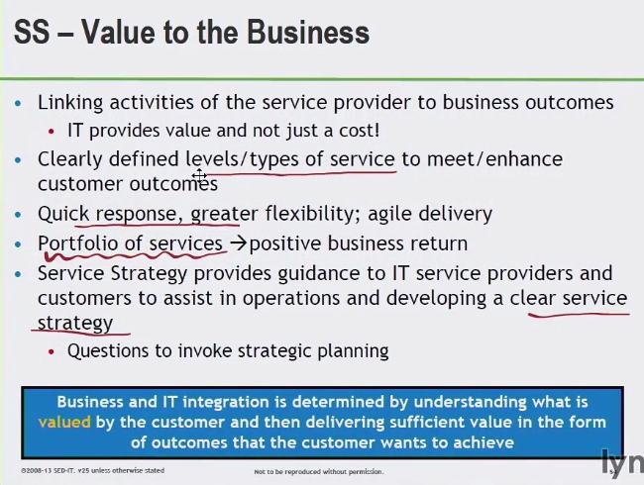

What services should we offer and to whom?

How do we differentiate from competitors?

What is the business case for strategic investment? What are the resources and allocation?

How do we define service quality?

**Service Design**

**Objective:** design services that min. Improvements are necessary during their life cycle

Design and develop services

If it’s new we’re putting it in, if retiring it or changing – go through appropriate design phase – blue printing

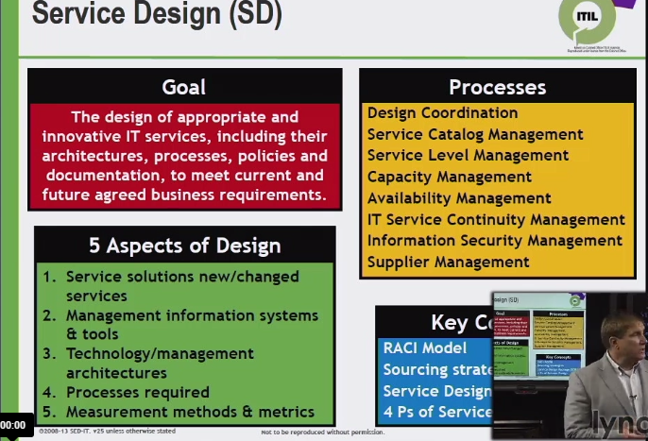

Des. Coord.

* Making sure all activities new and change are coord.

Catalog

* Current consistent info. On services – or becoming active services

SLM

* Documented the delivery req.
* Know req. from customer perspective – track & monitor

Capacity

* Takes needs from demands

Availability

* Current and future services – customer has those, uptime

Continuity

* Supports biz. Cont. plan
* Agreed availability in a major event – risk analysis

Security

* Policy aligned with biz. Objectives
* Confidentiality, integrity, availability of info

Supplier

* Keep track of supplies of those in delivery of those services

Responsible

Accountable

Consulted

Informed

Sourcing strategy

* How are we going to support and provide support – in/out/co-sourcing

Service Design Package

Culmination of the service design phase – defines all service aspects in their life cycle (SDP)

People Products Process

**Five Aspects of Service Design**

Not a change needs a design phase (not all the time)

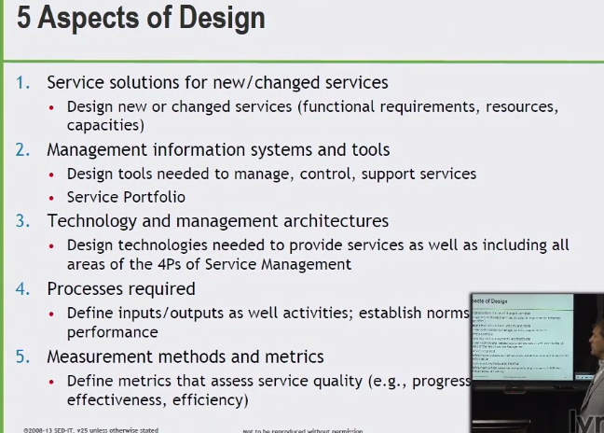

1. Documents – output -> service design package
2. Info systems and tools – continually review biz. Value – how we are supporting that service
3. Architecture – process, data, environ., policy, design, processes

People, process, products and partners – 4 p’s

Aka people process technology

1. Add/change/alter as a result
2. Metrics that assess service quality

***TIP*** STAPM

Service solutions, Tools, Architecture, Processes, measurement methods & metrics

**SERVICE DESIGN PACKAGE (SDP)**

* At completion – document or series of document – deliverable
* Service transtions/operations/csi

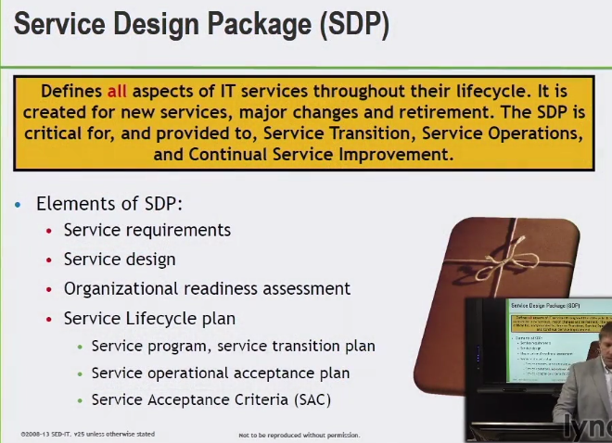

* Set the guidelines and guidance as it goes into service transition – and later phases of the life cycle